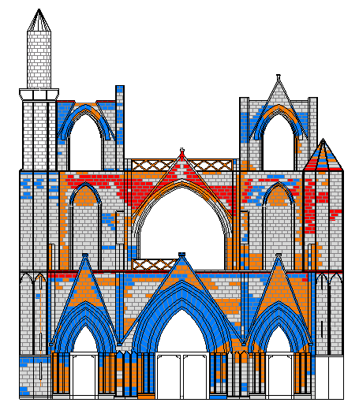
No discoloration (mostly original color)
Slightly discolored (orange)
Moderately discolored (gray)
Highly discolored (dark gray/black crust)
Figure 6.1Discoloration assessment of stone on Western façade
(Drawing and mapping by Y.M. Ibreighith)
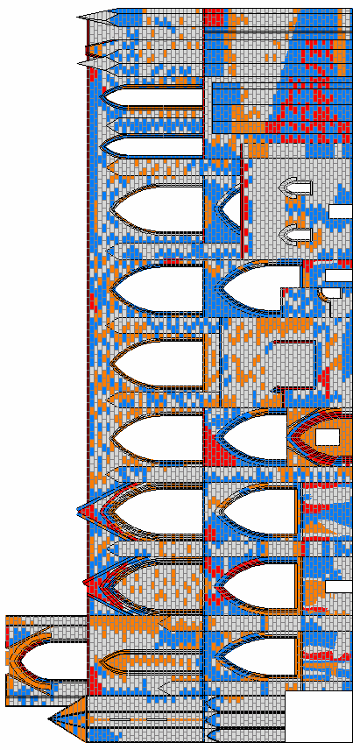
No discoloration (mostly original color)
Slightly discolored (orange)
Moderately discolored (gray)
Highly discolored (dark gray/black crust)

Figure 6. 2 Discoloration assessment of stone on southern façade
(Drawing and mapping by Y.M. Ibreighith)

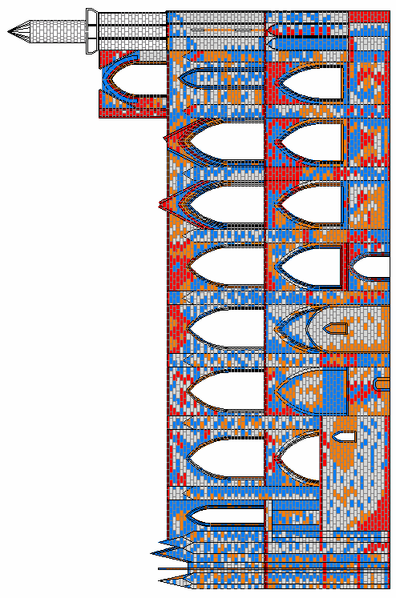

No discoloration (mostly original color)
Slightly discolored (orange)
Moderately discolored (gray)
Highly discolored (dark gray/black crust)
Figure 6.3 Discoloration assessment of stone on Northern façade
(Drawing and mapping by Y.M. Ibreighith)

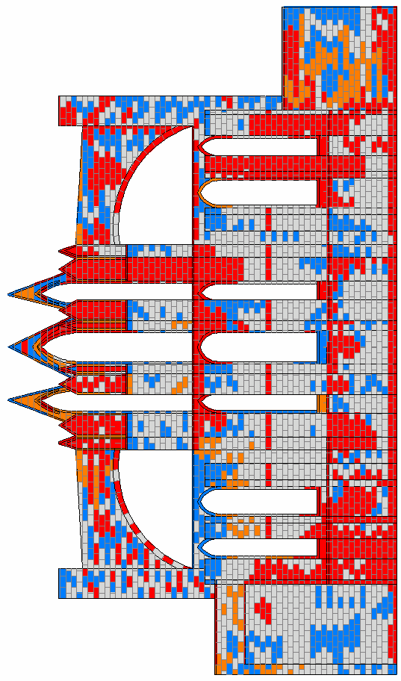
No discoloration (mostly original color)
Slightly discolored (orange)
Moderately discolored (gray)
Highly discolored (dark gray/black crust)

Figure 6.4 Discoloration assessment of stone on eastern façade
(Drawing and mapping by Y.M. Ibreighith)

